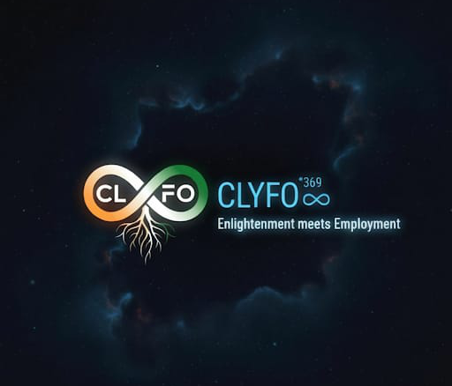 
™CLYFO^369(♾) Pvt Ltd – The Conscious Human OS for work from home Startup in the history of India under alignment of VIKASIT BHARAT-2047
Resourceful Reference of Ed-Tech Company:
https://idigitalpreneur.com/
Gmail: udaypurvak@gmail.com
Password: Udaypurvak#16
---------------------------------------------------
official base live pages:
https://clyfo-soul-sync.vercel.app/

https://clyfo-app.vercel.app/
--------------------------------------------------
Raw Landing Pages Links:
Gmail: udaypurvak@gmail.com
Password: Believer#16
0. All 6 integrated systems Page >> (1. World of Jnani, 2. Universe of HaiC, 3. CLYFO Cult , 4. CLYFO Circle, 5. CLYFO Connectivity, 6. CLYFO Foundation)
https://stitch.withgoogle.com/projects/17942948822231918719
https://stitch.withgoogle.com/projects/10409503465359593825
https://stitch.withgoogle.com/projects/5871795821198180812

- HOME PAGE:
https://stitch.withgoogle.com/projects/3038892991089307550

- ABOUT US PAGE:
https://stitch.withgoogle.com/projects/8639252267530092713\

- PHILOSOPHY + SCIENTIFIC PROOFS:
https://stitch.withgoogle.com/projects/11979251686793859826

- DUAL PROGRAMS PAGE:
https://stitch.withgoogle.com/projects/10768783420848813601

- 6 DIMENSION PILLARS PAGE:
https://stitch.withgoogle.com/projects/9208971825284701237

- 3-6-9 FRAMEWORK PAGE:
https://stitch.withgoogle.com/projects/13472024147381556338

Gmail: clyfo369@gmail.com
Password: Believer#16

- EARNING & IMPACT DASHBOARD PAGE:
https://stitch.withgoogle.com/projects/17531162856403611794

- ENLIGHTENMENT COURSE SERIES LIBRARY UI (Mobile App & Website Portal View) PAGE:
https://stitch.withgoogle.com/projects/4234277670490178505

- CERTIFICATIONS + RECOGNITION BADGE PAGE:
https://stitch.withgoogle.com/projects/1656011798344659626

- TESTIMONIAL / PROOF OF TRANSFORMATION PAGE:
https://stitch.withgoogle.com/projects/5248360864808033542

- TEAM PAGE:
https://stitch.withgoogle.com/projects/15827555365138905584

- LIVE WORKSHOP & EVENTS PAGE:
https://stitch.withgoogle.com/projects/17422818193856493674

- PORTAL LOGIN / SIGNUP PAGE:
https://stitch.withgoogle.com/projects/9970120024714809826

- A - CONTACT + COMMUNITY PAGE:
https://stitch.withgoogle.com/projects/12545753828004414369

Gmail: aup123aup@gmail.com
Password: Believer#16

- B - CONTACT + COMMUNITY PAGE:
https://stitch.withgoogle.com/projects/7307927266653496477

Gmail: udaypurvak@gmail.com
Password: Believer#16

- JOIN THE RE-BIRTH MOVEMENT PAGE:
https://stitch.withgoogle.com/projects/11809129165415234960

Need your holistic support for World Class Prototype Development from our Company above references, please look at & Observe to refine so many things at its Best unique ever.

